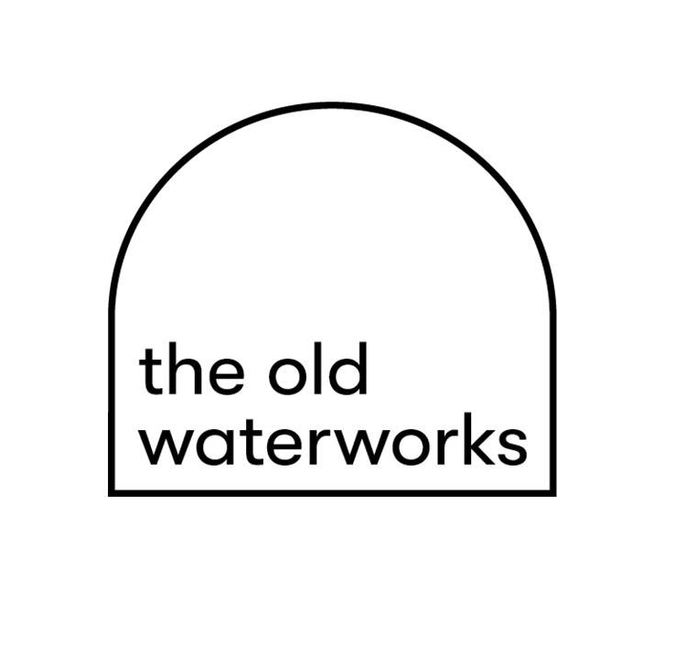
The Old Waterworks
Equal Opportunities Form

Please fill this form out however is easiest for you –
you can delete the options that don’t apply to you or
highlight the ones that do.

This information will be anonymous and deleted after the application process is complete.

1. Age *
What is your age?

16-17
18-21
22-30
31-40
41-50
51-60
60-65
65 and above
Prefer not to say

2. Gender *
What is your gender?
Female
Male
Non-Binary
Prefer to use your own term
Prefer not to say
If you prefer to use your own term, please specify here
_________________________________________________

3. Gender Identity *
Do you identify as trans?
Yes
No
Prefer not to say
If you prefer to use your own term, please specify here
______________________________________________________
4. Sexual Orientation *
What is your sexual orientation?
Heterosexual/straight
Gay man
Gay woman/lesbian
Bisexual
Queer
Prefer to use your own term
Prefer not to say
If you prefer to use your own term, please specify here
_________________________________________________

5. Ethnicity *
Ethnic origin is not about nationality, place of birth or citizenship. It is about the group to which you perceive you belong. What is your ethnicity?

British
English
Welsh
Scottish
Northern Irish
Irish Gypsy or
Irish Traveller
Any other White background
White and Black Caribbean
White and Black African
White and Asian
Any other Mixed / multiple ethnic background
Indian
Pakistani
Bangladeshi
Chinese
Any other Asian background
African
Caribbean
Any other Black / African / Caribbean background
Arab
Any other ethnic group
Prefer not to say
If you belong to another ethnic group please specify here
___________________________________________________

6. Religion *
What is your religion or belief?
No religion
Christian (including Church of England, Catholic, Protestant and all other Christian denominations)
Buddhist
Hindu
Jewish
Muslim
Sikh
Any other religion
Prefer not to say
Any other religion please specify here
__________________________________

7. Disability *
Do you consider yourself to be disabled under the Equality Act 2010?
The Equality Act 2010 defines a person as disabled if: they have a physical or mental impairment, the impairment has a substantial and long term adverse effect on their ability to perform normal day-to-day activities

Yes
No
Prefer not to say

